**Industrial Internship Report on**

**”New Smart Watch Social Media Strategy”**

**Prepared by**

**Maanas Sinha**

|  |
| --- |
| *Executive Summary* |
| This report provides details of the Industrial Internship provided by upskill Campus and The IoT Academy in collaboration with Industrial Partner UniConverge Technologies Pvt Ltd (UCT).  This internship was focused on a project/problem statement provided by UCT. We had to finish the project including the report in 6 weeks’ time.  My project was to Formulate a Social Media Strategy for a Product Launch (Smart Watch)  This internship gave me a very good opportunity to get exposure to Industrial problems and design/implement solution for that. It was an overall great experience to have this internship. |

**TABLE OF CONTENTS**

1 Preface 3

2 Introduction 4

2.1 About UniConverge Technologies Pvt Ltd 4

2.2 About upskill Campus 8

2.3 Objective 9

2.4 Reference 9

2.5 Glossary 10

3 Problem Statement 11

4 Existing and Proposed solution 12

5 Proposed Design/ Model 13

5.1 High Level Diagram (if applicable) 13

5.2 Low Level Diagram (if applicable) 13

5.3 Interfaces (if applicable) 13

6 Performance Test 14

6.1 Test Plan/ Test Cases 14

6.2 Test Procedure 14

6.3 Performance Outcome 14

7 My learnings 15

8 Future work scope 16

# Preface

In the duration of the 6 weeks internship, I was taught about different tools that can be used effectively for creating social media strategies for any product. I was also taught about the different analysis tools that can be used to measure performance of a media strategy.

The project helped me understand how companies do research about their markets and the processes they undergo in order to spread awareness about their products and brand.

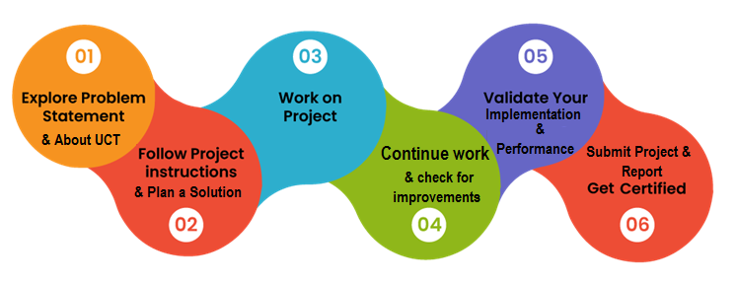

# Introduction

## About UniConverge Technologies Pvt Ltd

A company established in 2013 and working in Digital Transformation domain and providing Industrial solutions with prime focus on sustainability and RoI.

For developing its products and solutions it is leveraging various**Cutting Edge Technologies e.g. Internet of Things (IoT), Cyber Security, Cloud computing (AWS, Azure), Machine Learning, Communication Technologies (4G/5G/LoRaWAN), Java Full Stack, Python, Front end**etc.

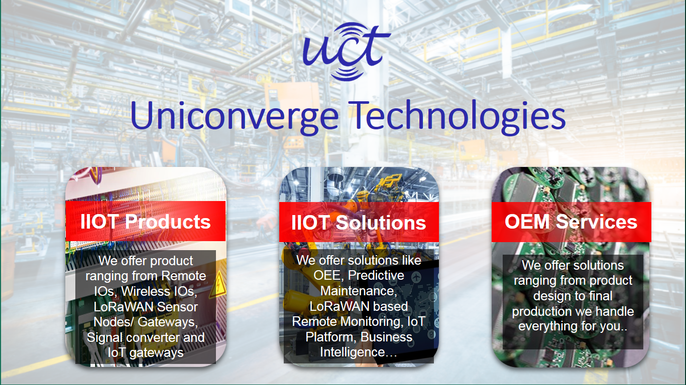

1. UCT IoT Platform **(****)**

**UCT Insight** is an IOT platform designed for quick deployment of IOT applications on the same time providing valuable “insight” for your process/business. It has been built in Java for backend and ReactJS for Front end. It has support for MySQL and various NoSql Databases.

* It enables device connectivity via industry standard IoT protocols - MQTT, CoAP, HTTP, Modbus TCP, OPC UA
* It supports both cloud and on-premises deployments.

It has features to  
• Build Your own dashboard  
• Analytics and Reporting  
• Alert and Notification  
• Integration with third party application(Power BI, SAP, ERP)  
• Rule Engine

 

1. **Smart Factory Platform (****)**

Factory watch is a platform for smart factory needs.

It provides Users/ Factory

* with a scalable solution for their Production and asset monitoring
* OEE and predictive maintenance solution scaling up to digital twin for your assets.
* to unleased the true potential of the data that their machines are generating and helps to identify the KPIs and also improve them.
* A modular architecture that allows users to choose the service that they what to start and then can scale to more complex solutions as per their demands.

Its unique SaaS model helps users to save time, cost and money.

 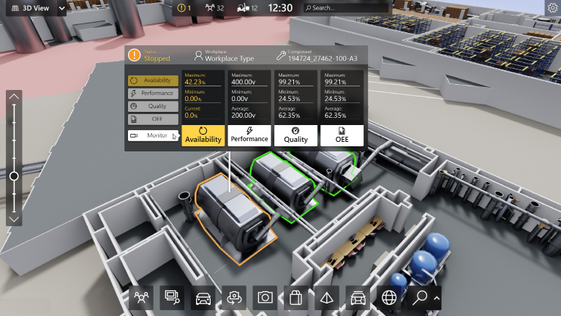

1. 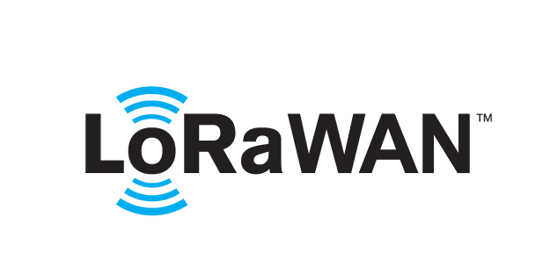 based Solution

UCT is one of the early adopters of LoRAWAN tecchnology and providing solution in Agritech, Smart cities, Industrial Monitoring, Smart Street Light, Smart Water/ Gas/ Electricity metering solutions etc.

1. Predictive Maintenance

UCT is providing Industrial Machine health monitoring and Predictive maintenance solution leveraging Embedded system, Industrial IoT and Machine Learning Technologies by finding Remaining useful life time of various Machines used in production process.



## About upskill Campus (USC)

upskill Campus along with The IoT Academy and in association with Uniconverge technologies has facilitated the smooth execution of the complete internship process.

USC is a career development platform that delivers **personalized executive coaching** in a more affordable, scalable and measurable way.



Seeing need of upskilling in self paced manner along-with additional support services e.g. Internship, projects, interaction with Industry experts, Career growth Services

<https://www.upskillcampus.com/>

upSkill Campus aiming to upskill 1 million learners in next 5 year

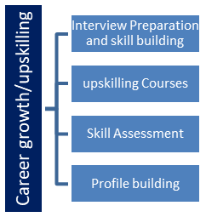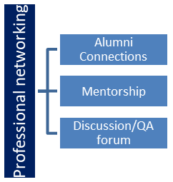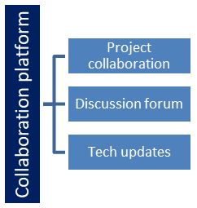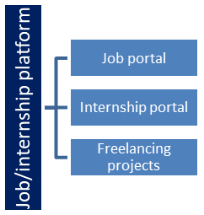

## The IoT Academy

The IoT academy is EdTech Division of UCT that is running long executive certification programs in collaboration with EICT Academy, IITK, IITR and IITG in multiple domains.

## Objectives of this Internship program

The objective for this internship program was to

 ☛ get practical experience of working in the industry.

 ☛ to solve real world problems.

 ☛ to have improved job prospects.

 ☛ to have Improved understanding of our field and its applications.

 ☛ to have Personal growth like better communication and problem solving.

# Problem Statement

An electronics company is planning to launch a new product in the market, which is a smartwatch. There is a need to formulate, implement and execute an effective social media campaign for the product which is to be launched in the market. This campaign should help increase awareness about the product.

## Code submission: https://maanas15-obscure-dollop-69gr7rp5qj56f46pq.github.dev/

## Report submission: https://github.com/maanas15/Digital-Marketing-Project/upload/main

**3.3 Product review**

Our new smartwatch **“SFit”** offers the following features:

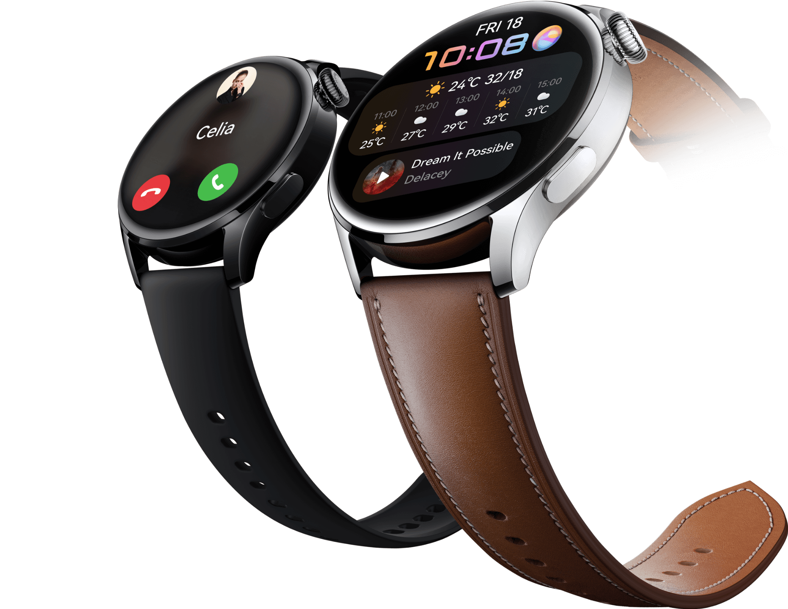

**Specification:**

Specification:

|  |  |  |
| --- | --- | --- |
| **NETWORK** | **Technology** | **HSPA/LTE** |
| LAUNCH | Announced | 2022, March 01 |
|  | Status | Available. Released 2022,  April 01 |
| BODY | Dimensions | 46 x 39 x 11.4 mm (1.81 x 1.54 x 0.45 in) |
|  | Weight | 40 g (aluminum) / 45.5 g (stainless steel) (1.41 oz) |
|  | Build | Glass front, stainless steel frame or aluminum frame, ceramic/sapphire crystal back or plastic back |
|  | SIM | eSIM (market/region dependent) |
| DISPLAY | Type | AMOLED |
|  | Size | 1.91 inches |
|  | Resolution | 402 x 476 pixels (~326 PPI density) |
|  | Protection | Schott Sensation Up (46mm), Corning Gorilla Glass (41mm) |
| PLATFORM | OS | Android Wear OS - International ColorOS Watch OS - China |
|  | Chipset | Qualcomm Snapdragon Wear 3100 (28 nm) - International Qualcomm MSM8909W Snapdragon Wear 2500 (28nm) - China |
|  | CPU | Quad-core 1.09 GHz Cortex-A7 |
|  | GPU | Adreno 304 |
| MEMORY | Card Slot | No |
|  | Internet | 8GB 1GB RAM |
|  |  | eMMC 4.5 |
| CAMERA |  | YES |
| SOUND | Loudspeaker | Yes |
|  | 3.5 mm audio jack | No |
| COMMS | WLAN | Wi-Fi 802.11 b/g/n |
|  | Bluetooth | 4.2, LE |
|  | GPS | Yes, with A-GPS, GLONASS, BDS |
|  | NFC | YES |
|  | Radio | NO |
|  | USB | NO |
| FEATURES | Sensor | Accelerometer, gyro, heart rate, compass, barometer |
| BATTERY | Type | Li-Ion 430 mAh, non-removable |
| MISC | Colors | Black, Red, White, Sky blue |

**3.4 Competitive Review:**

As sales of Smartwatches entered a strong growth phase in 2019, the category began to expand. So new marketers emerged. In the Bangladesh market, the prices of Smartwatches are quite reasonable. For now, no other company in Bangladesh is providing such smartwatches at the price of 1490 except **“SGadget”.**

**Haylou Solar LS05**

Despite being one of the underdogs of the smartwatch business, Haylou is immensely popular globally as well in Bangladesh. Solar LS05 is an amazing round screen wearable and a must-buy if you want to accurately track your fitness activities at an unbelievably affordable price. But make sure you are ok with the low-resolution screen before buying. Price: Tk 2,400-2,900/-

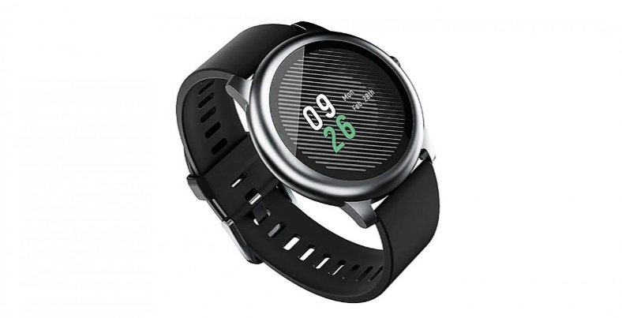

**Amazfit GTR**

Gaining its popularity in late 2018, Amazfit has spawned one great wearable after another in the last couple of years. And GTR is one of its most popular models available now. Its superb design gets outshined by its even superior performance. Although many disputes the accuracy of activity tracking, no one will challenge its unrivaled battery backup claims. (Price: Tk. 10,500-12,500/-)

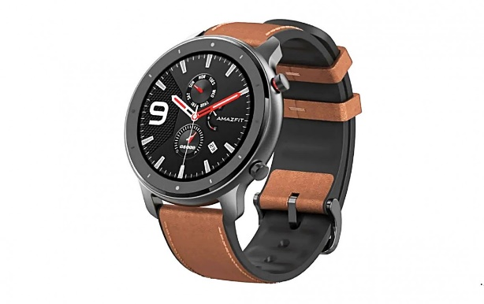

**Xiaomi Mi Band 5**

With a relatively bigger display on a narrow band, Xiaomi Mi Band 5 has created quite the craze in the market. It offers above-average sports tracking, superb battery backup, and decent value for money. (Price: Tk. 3,000-3,500/-)

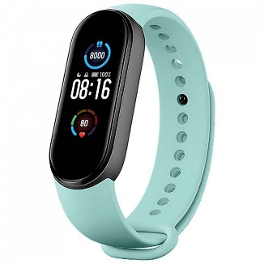

**Huawei Watch GT2e:**

This is the priciest wearable on our list and for good reason. This stylish smartwatch has a vibrant display yet still it manages to offer a pretty good battery life. Its excellent tracking feature is only a bit marred by the lag you might experience while interfacing with your smartphone. (Price: Tk. 13,500-14,000/-)

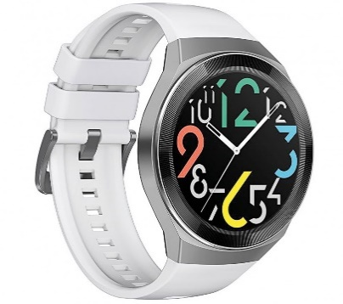

REF: <https://www.thedailystar.net/youth/careers/outsourcing/news/thriving-freelancers-young-professionals-share-their-experience-2162106>

Despite the strong competition, ‘We3 Gadget’ believes it can create a relevant brand image and gain recognition among the targeted segments. The brand offers strong points of differentiation with higher and unique features at a lower price than other brands.

**3.5 Channels and Logistics Review:**

Logistics Channel refers to a community that entails all the contributors of the delivery chain engaged in functions like transportation, receiving, managing, warehousing, facts sharing, and many others. A green logistic channel is pre-needful for acquisition and keeping of clients because it facilitates businesses to supply their goods to their clients at right time in the right situation. increase in product variety has additionally led to need of stepped forward logistic channel.  
  
The numerous dreams of logistics channel are as follows:  
• meeting customer support stage  
• reduce cost  
• multiplied sales  
• building courting for higher logistics execution

‘‘SGadget’’ will use a special distribution strategy with well-known local and national property suppliers, retailers, retailers, and online retailers. This distribution strategy will be implemented through an established network of private vendors and retailers operating on a national scale. This strategy will work better in ‘SGadget’ ’compared to other major Smartwatch manufacturers because they usually focus on one or two vendors across the country instead of trying to expand to other distribution and distribution channels. "SGadget" will also focus on corporate collaboration, as well as collaborations with major technology content creators and runners to ensure more public coverage that could lead to another distribution channel. And about material use, "SGadget" will work with international transport partners such as RedX and Pathao. This will ensure that consumers can purchase “SGadget” Smartwatches in all regions, even if there are no vendors available. This will close the market gap that many smartwatch manufacturers are struggling to fill and “SGadget” will gain power over them. This will also give "SGadget" the power of how much the market can take instead of trying to compete for shelf space in supermarkets. As a result of cutting the competition by securing partnerships with transportation partners, SGadget will be able to gain more control over regions that do not have the right stores. Expected vendors for the "SGadget" partner include:

• “SGadget”: considered one of the most important customer vendors in the USA that functions in a couple of regions and also offers logistics aid to get merchandise across one-of-a-kind areas.

• International Brand: Massive distributor and provider for smaller retail shops everywhere in the country. Additionally, they accommodate huge corporate orders which would ensure that “SGadget” is capable of supplying agencies consistent with their demands as well.

**4.0. “sGadget’s” SWOT analysis:**

**4.1. Strength -**

* Watch is beautifully designed.
* Best smartwatch out there
* Less invasive than a phone
* Can be synced with your phone for a seamless transition
* Easy to review arts and notifications.

**4.2. Weakness -**

* Price is not the best
* Still need to have a phone with you.
* Some apps don't work properly.
* Battery life.

**4.3. Opportunities -**

* Different styles to suit every individual.
* Beginning of a new era
* Can respond to notifications with a voice very easily.

**4.4. Threats** -

* Aggressive competition
* Emergence and growth of Chinese companies
* Highly dynamic market and changing consumers perceptions
* Other companies can be more price effective and offer more services

**5. Objectives and Issues:**

Marketing goals are defined product objectives. They explain the objectives of the marketing team, provide clear guidance for team members to follow, and provide information for management to review and support.

Marketing goals are an important part of marketing strategy. Without stated intentions, the product will struggle to achieve its goals because it will not be clear what it wants to do.

**5.1. First-year objectives**:  
SGadget‘s objective for its first year available on the market is to build the emblem and seize 10% of the national smartwatch market. “SGADGET” additionally desires to achieve 2 million takas in sales. all through this period, Cadence 1.0 additionally desires to set up a straightforward emblem photo.

**5.2. Goals for the Second Year:**

SGadget's second-year goal is to replicate last year's sales and create more distribution channels to gain a larger share of the smartwatch market.

**5.3. Objectives of the Third Year:**

To maintain its success last year, “sGadget” aims to provide additional resources for the development of its next smartwatch during its third year in the market and sGadget also seeks to capture a large international market.

**5.4. Issues:**

A major challenge in developing this new model is the ability to create product awareness and a positive brand image based on targeted customer groups. sGadeget must complete the construction of a smartwatch with a limited budget and resources.

"sGadget", is a new business that is trying to capture the bulk of the smartwatch

in the market, he has to work hard to achieve success.

**6. Marketing Strategy**

A marketing strategy is a plan that can allow an organization to focus its limited resources on greater opportunities to increase sales and gain continuous competitive profit.

A marketing strategy is a long-term and comprehensive plan for any business with the ultimate goal of creating an effective competitive edge by providing customer needs and requirements.

The marketing strategy of "SGADGET" means to develop a place 'more and less'. Because the brand will be located in areas where major competing companies are absent, it will produce channel segregation. Low-income people, especially young people, will be the first beneficiaries of SGADGET.

**7. Positioning**

Market Positioning refers to the ability to influence consumers' perceptions about a product or product related to competitors. The purpose of a market stand is to get a picture or identity of a product or product so that consumers can see it in a certain way.

“SGADGET” focuses on marketing strategy for the ‘small majority’ proposal to capture the attention of a large number of customers. Various smartwatch models are currently competing for market share by providing fast and high-quality service to consumers. With the rapid development of technology, people have had to adapt to the changes brought about by globalization. Many firms today can enter the market by selling smartwatches to consumers and constantly giving them new designs from time to time.

**8. Product Strategy:**

“**SGadget”** will think back to all of the details described in the Product Reviews section.

Further details and variants will be given as sales and profits increase and the marketable availability expands. We aim to provide our customers with products that are both flexible and of outstanding quality. We will ensure you that the smartwatches are not deficient in any technique to other smartwatches on the market in a comparable price range since we created them in-house.

**9. Pricing:**

We are offering 3 types of watches with different variants. According to the features, the watch has 3 models:

|  |  |  |
| --- | --- | --- |
| Model name | Features | Price (BDT) |
| SFit Model 1 | Water resistance, Alarm. | 1500 |
| SFit Model 2 | Water resistance, Alarm, Scanning and payment method, Safety and security alarm. | 2000 |
| SFit Model 3 | Water resistance, Alarm, Scanning and payment method, Safety and security alarm, Location tracker, Heart rate & pulse measurement. | 2500 |

People on all budgets can afford our smartwatch. SFit model 1 price is 1500. It has Water resistance, Alarm features. This is our most reasonable watch. People whose budget is around 1500 can buy our smartwatch. SFit model 2 is for a mid-budget range of watches. It has Water resistance, Alarm, Scanning and payment method, and Safety and security alarm features. People whose budget is around 2000 can buy this watch and can enjoy these awesome features. Our highest budget range watch is SFit model 3. It has Water resistance, Alarm, Scanning and payment method, Safety and security alarm, Location tracker, Heart rate & pulse measurement features. People whose budget is around 2500 can buy and enjoy this watch. We have a budget smartwatch with awesome features.

**9.1 Distribution Strategy**

Smart tech goods are available for purchase on the company's website, on e-commerce sites such as Daraz, and in retail locations. Apart from the internet, the “SFit” marketing mix also includes retailers and shops. Various showrooms, dealers, and distributor locations may be found throughout the world. “SGadget” uses several promotional strategies to reach out to potential customers. “SFit” marketing mix focuses on 360 branding, which includes TV, print media, and online ads, among other things. SGadget needs to build it with the client in mind because we're releasing a professional laptop on a tight budget. SGadget also does all possible to provide excellent service on a tight budget.

**9.2. Marketing Communication strategy**

A marketing communications strategy is a way to inform potential consumers about a product or service. In addition, the plan must contain the marketing mix, which defines and describes the many strategies of product promotion within its strategy for reaching out to its intended audience. The major objective is to use community involvement and media engagement to assist create brand recognition and trust among target customers.

As SGadget is a new product in the market which wants to deliver quality full smartwatches on a short budget. So, the main potential customers for SGadget are mostly students or teenagers. To reach out or communicate to young age people, SGadget can use various social media platforms like Facebook, YouTube, Twitter, Instagram, etc. Our commercial communication plan for the “SGadget‘s SFit” will not be based on a normal mass communication strategy. There will be two types of promotional materials for “SFit”. These two types are online and mobile marketing and trade promotion.

**9.2.1.Online and mobile marketing:**  The average target client of NutriWater spends more time online than on traditional media channels. So, the creation of the internet and mobile brand sites will be an important part of this approach. Young people who spend a lot of time online are the primary target audience for “SFit”. As a consequence, advertisements on social media sites including Twitter, Facebook, Instagram, and YouTube will be permitted. “SGadget” may use famous YouTubers to market our products.

**9.2.2.Trade promotions:** Relationships with retailers will be critical to SGadget’s success in creating product availability. Point-of-purchase displays, branded coolers for smartwatches, and other products will be among the primary incentives for merchants. This push marketing strategy will be used in conjunction with other pull marketing strategies.

1. **Action program :**

|  |  |  |
| --- | --- | --- |
| Program | Objective | Duration |
| Making 1-minute brand and product intraday introductory ad through social media and mass media (tv, Billboard magazine) | for creating brand awareness | January - 15th March |
| Identifying the potential consumer on Facebook to posting the poster of product details | for reaching consumer knowledge | 16th March-May |
| Sponsoring and posting digital gadget related shows on YouTube | for gauging more consumers with the brand and grabbing the attention of the customer | March - December |
| Making a page on Facebook named “sGadget” by which users will share their experiences regarding the product | for increasing positive word of mouth | May -December |
| 10 second YouTube and Facebook video interrupting add | For positioning the brand name in the consumer’s mind | July -September |

1. **Budget**: For the beginning of our brand, We have decided that we will start our business with 20 lakh taka, we will distribute the capital in the following ways :

* .10% on Website building.
* 10% on Management
* 25% on Advertisement
* 10% on product Development
* 20% on product Raw materials
* 15% on Employee’s salary
* 5% on Emergency fund
* 5% on the utility bill

**11.1.Controls**: Product control is mainly concerned with compiling profit and loss accounts from products traded by the front office daily. Producing monthly and quarterly financial reports. By this, we can understand the product positions on the market and ensure a strong and efficient control environment to minimize operational risk.

We can interact with Trading as you are ultimately finalizing our product with profit or loss. Depending on the product you support- (can be a vast category of products, vanilla equity/fixed income/exotics)-very good chance to get an idea of different trading strategies.

**11.2. Findings**:  according to the methodology part we have found some Challenges in our product that can be solved. The first one is the product durability. How much durability does this product have? This watch is not made of metal So in case of heavy pressure, this watch will be broken into pieces which is a big problem. the second one is in case of high temperature our product will not work as well as before for its Perception of heating. So, to use this product, we will recommend to our consumers Do not to use our product in high-temperature areas. In our product, we are giving some of the best features. There is another problem which is the Budget of the consumer. South this problem we have come up with three different Smartwatches with low price, medium price, and High price.

**11.3.Recommendation**: In the age of modern science so people try to become More Digitized in Every step of life and smartwatches become a part of digital life. In recent years, the demand for faster smartwatches has increased worldwide. However, most smartwatch companies do not pay attention to making them available to everyone at a more affordable price. But as more companies dig into it, they will pay more attention to and saturate this niche in the market. Otherwise, the giants wouldn't choose this strategy. They would prey on their expensive flagship lineup because they didn't want it. However, this advance means that many people miss the experience of more affordable smartwatches, which can improve their experience efficiency by a significant percentage.

1. **Conclusion**

 Either way, it's good for the consumer as it gives them more options to choose from, meeting their needs and pocket. We are giving them the best product at a reasonable price. Our product has more features than other Smartwatches on the same range Budget. Believe that if we make a product value with customer satisfaction we can create a big image in the Smartwatch industry and future it will Increase our brand value.

.